Name: ………………………………. Date: ……..…… Class: …......

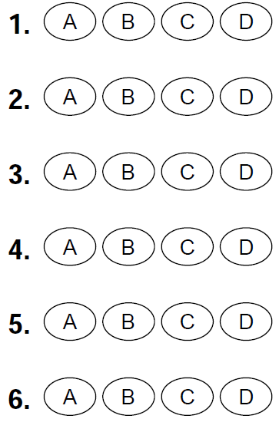
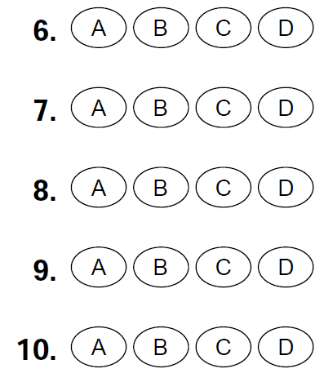
Q.1. Choose the correct answer:

- 3 X 500 = ………….
- 3500 b) 1500 c) 15 d) 500

- 800 X 5 = ………….
- 400 b) 4 thousands c) 850 d) 40

- 7 X 6 thousands = …………….. Thousands.
- 7 b) 6 c) 42 d) 42,000

- 8500 = ……… Tens.
- 850 b) 85 c) 85000 d) 80

- 852,672 rounded to the nearest thousand to be …………….
- 852,000 b) 853,000 c) 3,000 d) 852,700

Q.2. Put < , > or = :
- 300 thousands …………=………. 3000 hundreds.
- 55 thousands …………<………... 500 hundreds. Stop
- 132,045 …………<………… 32,045 Think
- 581,205 …………>………… 581,705 Go
Q.3. Think and answer:
a) In 2018, a toy factory produces 1,200 duck toys, 4,550 ball toys and 670 bear toys, what is the total number of toys did they produce in 2018?
…………………………………………………………………………………
………1,200 + 4,550 + 670 = 6,420………………………………………..
…………………………………………………………………………………
- In 2017, there were 270,624 tourists visited the Karnak temple, In 2018
795, 851 tourists visited the temple, how many fewer tourists visited the temple in 2017?
..................................................................................................................
……795,851 – 270,624 = 525,227………………
………………………………………………………………………………

- Ahmed and Ali went to Magic Galaxy, Ahmed played 3 times as many as Ali, Ahmed played 18 games so, how many games did Ali play? How many more games did Ahmed play than Ali?
3 X n = 18
n = 18 ÷ 3 = 6 so, Ali = 6
More = Ahmed – Ali =
18 _ 6 = 12

