Name : ………………………………... Date : ………… Class : ……
Homework sheet (6)

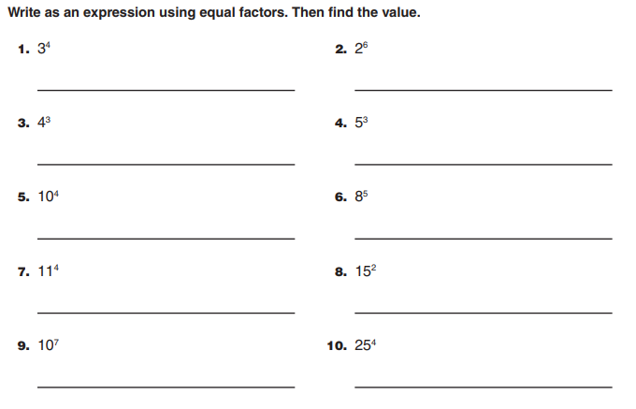
4x4x4 = 64
25x25x25x25 = 390,625
10x10x10x10x10x10x10 = 10,000,000
15x15 = 225
11x11x11x11 = 14,641
8x8x8x8x8 = 32,768
10x10x10x10 = 10,000
5x5x5 = 125
2x2x2x2x2x2 = 64
3x3x3x3 = 81

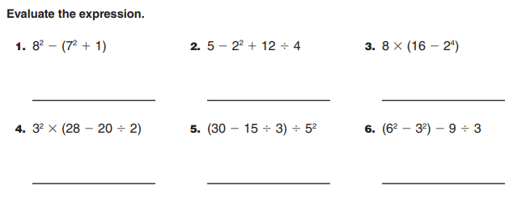
14
24
1
162
0
4

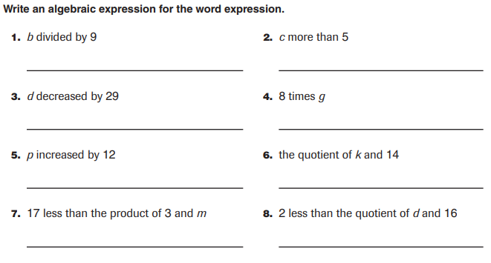
d - 29
(d ÷ 12) - 2
3m - 17
k ÷ 14
p + 12
8g
c + 5
b ÷ 9

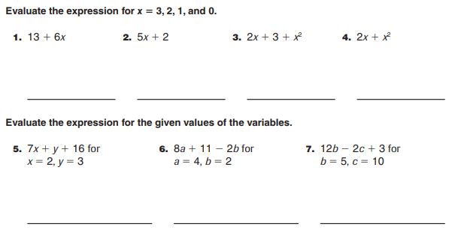
43
39
33
15
8
3
0
18
11
6
3
17
12
7
2
31
25
19
13

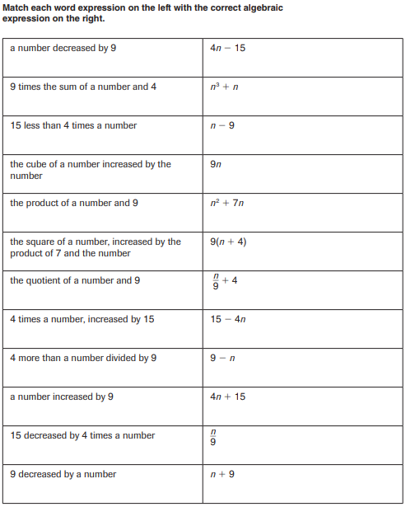
10
7
8
12
11
9
2
6
5
1
4
3

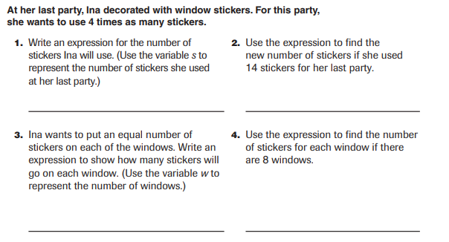
7 stickers
56 ÷ w
56 stickers
4s

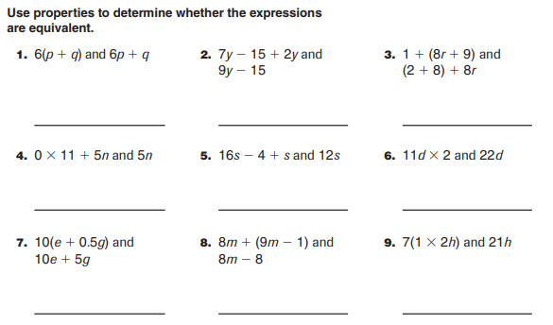
Not Equivalent
Not equivalent
Equivalent
Equivalent
Not equivalent
Equivalent
Equivalent
Not equivalent
Equivalent

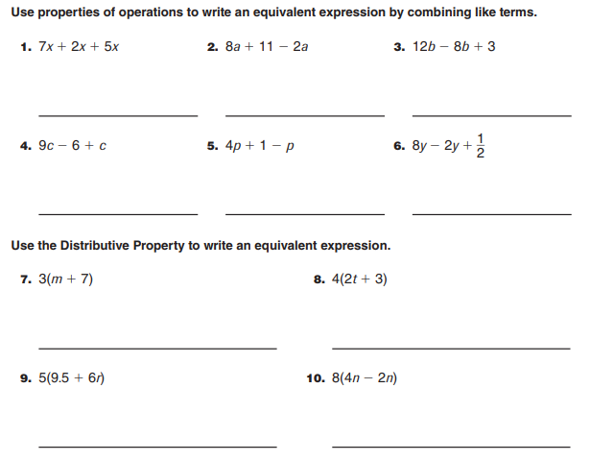
16n
47.5 + 30r
8t + 12
3m + 21
6y + $\frac{1}{2}$
3p + 1
10c - 6
4b + 3
6a + 11
14 x

